CS 255 System Design Document Template

This template lays out all the different sections that you need to complete for Project Two. Each section has guidance to prompt your thinking. You will need to continually reference the interview transcript as you work to make sure that you are addressing your client’s needs. There is no required length for the final document. Instead the goal is to complete each section based on what your client’s needs are. Remove this note when you are finished, and replace all bracketed text with the relevant information.

UML Diagrams

UML Use Case Diagram
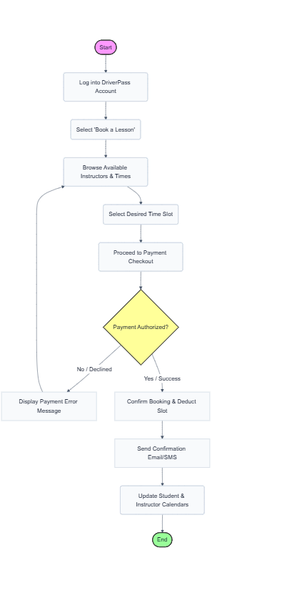

UML Activity Diagrams
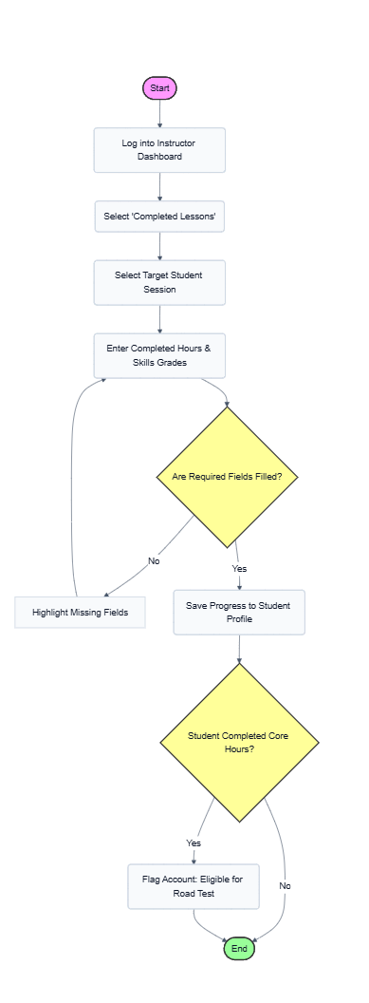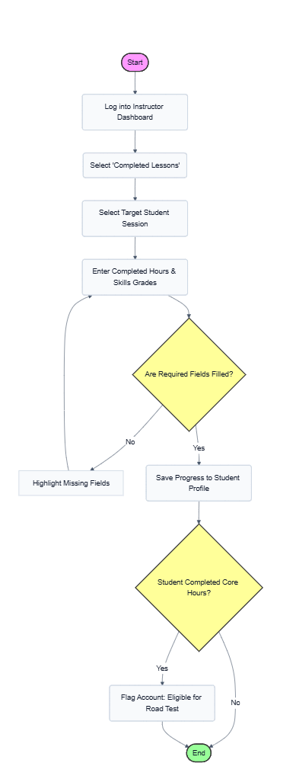

UML Sequence Diagram
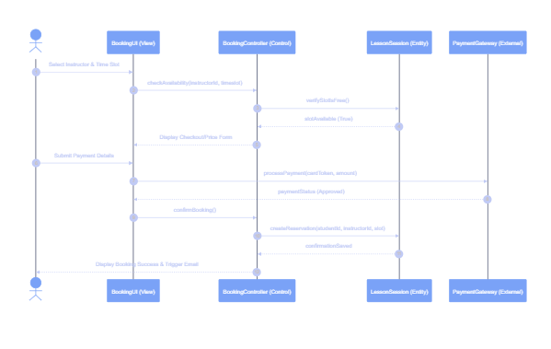

UML Class Diagram
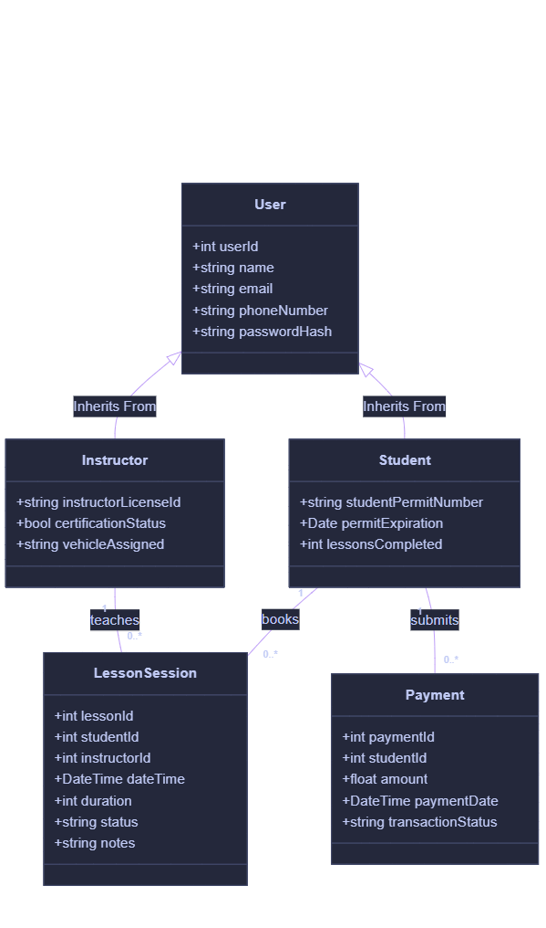

Technical Requirements
Based on the UML diagrams and the functional requirements gathered for DriverPass, the system needs a reliable, modern tech stack that keeps student data secure, handles scheduling without conflicts, and runs smoothly on both desktop and mobile screens.
Hardware Requirements
- Cloud Hosting Servers: We don’t need physical on-premise hardware for this. The application and database will be deployed on cloud virtual machines (like AWS EC2 instances or DigitalOcean Droplets). We will configure basic auto-scaling so the system can handle traffic spikes when students rush to book lessons at the start of the week.
- User Devices: On the client side, the system must be lightweight enough to run smoothly on standard consumer hardware. This includes student and instructor smartphones (iOS and Android) and any standard laptop or desktop running an updated web browser (Chrome, Safari, Firefox, or Edge).
Software & Tools
- Frontend Framework: The user interface will be built using React.js (for the web app) or a cross-platform framework like Flutter. This ensures the UI is completely responsive, meaning the booking calendar and dashboard auto-adjust layout whether an instructor views it on a tablet or a student opens it on a phone.
- Backend Runtime: We will use Node.js with Express (or Python with FastAPI) to build the RESTful API. This backend will handle the core controller logic, routing things like availability checks and booking confirmations between the user interface and the database.
- Database Management System (DBMS): A relational database is necessary here to prevent scheduling conflicts (like two students booking the same instructor at the same time). We will use PostgreSQL because its ACID compliance guarantees transactional integrity for schedule updates and payment records.
Infrastructure & External Integrations
- Database Hosting: To ensure we don't lose student records or progress logs, we will use a managed database service like AWS RDS. This automatically handles nightly backups and keeps the database highly available.
- Payment Gateway API: To avoid the massive security liability of storing credit card numbers, the system will integrate with the Stripe API. Stripe will handle the checkout flow, process payments externally, and simply return a secure success token back to our PaymentGateway module.
- Notification Engine: The system will connect to Twilio (for SMS) and SendGrid (for emails). The backend will trigger these services automatically to send immediate confirmation alerts and lesson reminders to both students and instructors.

